3.MODIFIED EULER’S METHOD

AIM: TO WRITE A PROGRAM IN PYTHON TO DEMONSTRATE MODIFIED EULER’S METHOD
PROGRAM:
# Modified_Euler's_Method.py
# Equation: dy/dx = x^2 + y, y(0) = 1
# Find y(0.2) with step size h = 0.02

def f(x, y):
"""The ODE: dy/dx = x^2 + y"""
return x**2 + y

# Initial conditions
x0 = 0
y0 = 1
h = 0.02
x_end = 0.2
n = int((x_end - x0) / h) # Number of steps: (0.2 - 0) / 0.02 = 10

# Table header
print("-----------------------------------------------------------------------------------------")
print("i | x(i) | y(i) | f(x(i),y(i)) (f1) | y'(Pred) | f(x+h, y') (f2) | y(i+1)")
print("-----------------------------------------------------------------------------------------")

# Print initial condition (Step 0)
print(f"{0:<2d} | {x0:10.6f} | {y0:10.6f} | {'':20} | {'':10} | {'':20} | {'':10}")

# Iterative Modified Euler Calculation
# 1. Predictor (Standard Euler): y* = y_i + h * f(x_i, y_i)
f1 = f(x0, y0)
y_pred = y0 + h * f1

# 2. Corrector (Heun's Formula): y_i+1 = y_i + (h / 2) * [ f(x_i, y_i) + f(x_i+1, y*) ]
x_next = x0 + h
f2 = f(x_next, y_pred)
y_next = y0 + (h / 2) * (f1 + f2)

# Print intermediate results for the current step (i+1)
print(f"{i+1:<2d} | {x_next:10.6f} | {y0:10.6f} | {f1:20.6f} | {y_pred:10.6f} | {f2:20.6f} | {y_next:10.6f}")

# Update for next iteration
x0 = x_next
y0 = y_next

print("-----------------------------------------------------------------------------------------")
print(f"h = {h:.2f}, Number of steps = {n}")
print(f"Formula used:")
print(f"y*(i+1) = y_i + h * f(x_i, y_i) (Euler Predictor)")
print(f"y(i+1) = y_i + (h/2) * [ f(x_i, y_i) + f(x_i + h, y*(i+1)) ] (Heun Corrector)")
print(f"Approximate value of y({x_end:.1f}) = {y0:.6f}")
print("-----------------------------------------------------------------------------------------")

OUTPUT:
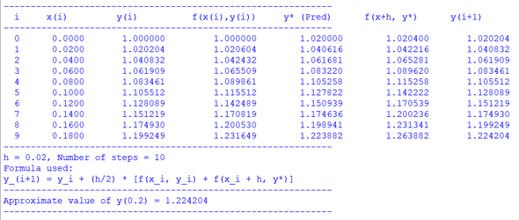
CONCLUSION:
THE ABOVE PROGRAM HAS BEEN EXECUTED SUCCESSFULLY.

